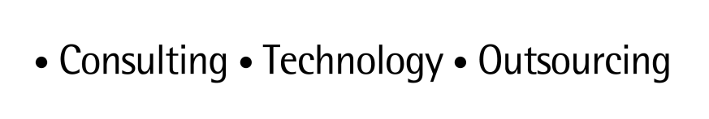

**ARTL for Java**

Java Technical Good

**<C0001-MongoDB-MongoDBExample>**

*Installation and Configuration Guide*

*Feb 2015 version 1*

Contents

1 TECHNICAL GOOD CODE 3

1.1 Source Code 3

1.2 Dependencies 3

2 BUILD 3

3 INSTALLATION 3

3.1 Pre requisites 3

3.2 Installation process 3

3.3 Verification 4

3.4 Known issues and FAQs 5

4 CONFIGURATION 5

4.1 Pre requisites 5

4.2 Configuration files 5

4.3 Configuration data 5

4.3.1 Mandatory data 5

4.3.2 Optional data 5

5 AUDIT 5

5.1 Logging configuration and audit 5

6 CODE SAMPLES 5

6.1 Technical Good code samples 5

5

7 DOCUMENT CONTROL 6

7.1 Change history 6

7.2 Open issues 6

# TECHNICAL GOOD CODE

## Source Code

Source code is uploaded in ARTL along with these documents. Please download the same and follow the installation process as mentioned in the document.

## Dependencies

Attached is the pom.xml which has all entries for required jar to run the examples.



# BUILD

We are using **Maven** as build tool for the MongoDB project . Use simple maven commands (mvn clean , mvn install , mvn package) for clean , build and packaging the project.

# INSTALLATION

## Pre requisites

**Development tool :** We have used eclipse(with maven plugin) for developing and running the examples.

**Build tool :** We are using maven as build tool .

**DB server :** MongoDB (Install MongoDB as mentioned in the document MongoDB-QSU Guide v.1.00.docx)

**Java Version :** We have used JAVA 6 for compiling and running the code.

## Installation process

Download the project zip file (MongoDB.zip) . Unzip the zip file. And you can import sample code in eclipse. Refer below screenshots.

Go to Navigator mode 🡪 right click 🡪 click on import 🡪 select maven 🡪 Existing maven project into workspace

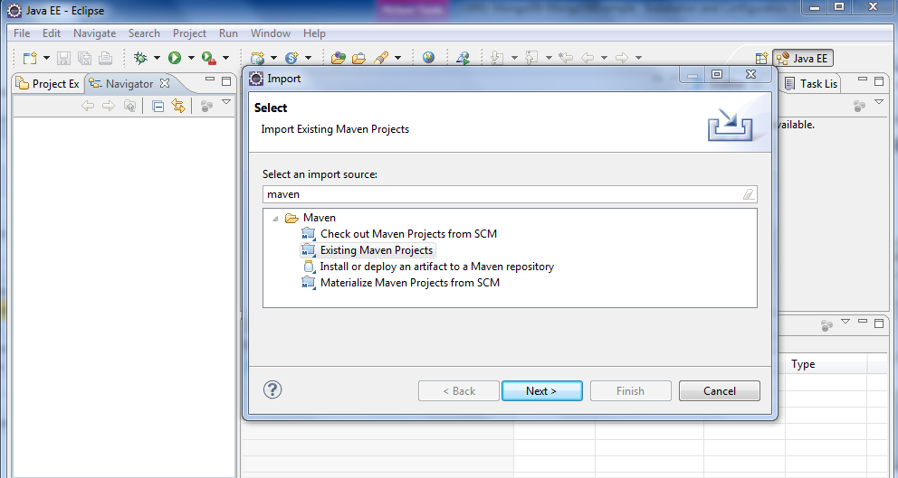

Then browse for unzipped example project and select that and click next and then click finish. And you can see the example in your workspace.

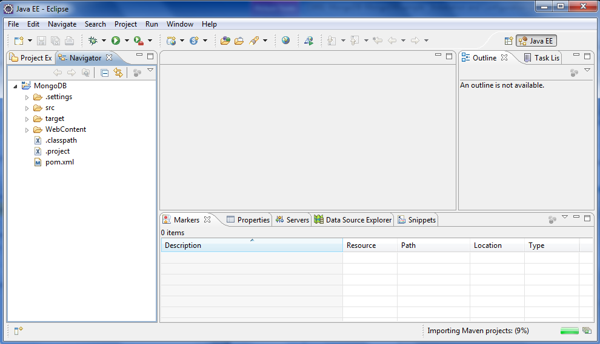

## Verification

Example project will be seen in workspace after import.

Then from command line go to location where there is pom.xml is. [e.g C:\bper\workspace\MongoDB]

And then run the below command:

mvn clean install

This command will clean the project , download the dependencies if they are not present in the local maven repo and create the war of the project in the target and local maven repo folder.

See below screenshot for reference.

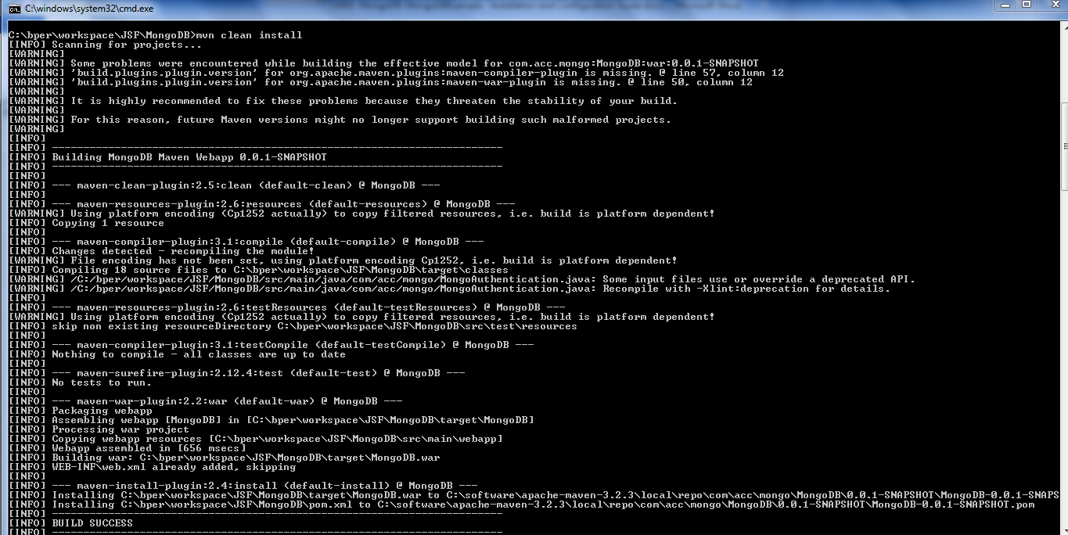

## Known issues and FAQs

# CONFIGURATION

## Pre requisites

NA

## Configuration files

NA

## Configuration data

### Mandatory data

NA

### Optional data

NA

# AUDIT

## Logging configuration and audit

System outs are added and can be seen on terminal when you run the examples as java application.

# CODE SAMPLES

## Technical Good code samples



# DOCUMENT CONTROL

## Change history

|  |  |  |  |  |  |
| --- | --- | --- | --- | --- | --- |
| **Doc Version** | **Date** | **Asset Version** | **Author** | **Approver** | **Comment** |
| 1 | 15/06/2015 | 1 | Ashish Agarwal |  |  |
|  |  |  |  |  |  |
|  |  |  |  |  |  |
|  |  |  |  |  |  |
|  |  |  |  |  |  |
|  |  |  |  |  |  |
|  |  |  |  |  |  |
|  |  |  |  |  |  |

## Open issues

|  |  |  |  |  |  |  |
| --- | --- | --- | --- | --- | --- | --- |
| **Doc Version** | **Date** | **Asset Version** | **Author** | **Action** | **Owner** | **Status** |
|  | mm/dd/yyyy |  | <enterprise.id> |  | <enterprise.id> |  |
|  |  |  |  |  |  |  |
|  |  |  |  |  |  |  |
|  |  |  |  |  |  |  |
|  |  |  |  |  |  |  |
|  |  |  |  |  |  |  |
|  |  |  |  |  |  |  |
|  |  |  |  |  |  |  |